**Hands on 1**

**Create a Spring Web Project using Maven**   
SME to walk through the following aspects related to the project created:

1. src/main/java - Folder with application code
2. src/main/resources - Folder for application configuration
3. src/test/java - Folder with code for testing the application
4. SpringLearnApplication.java - Walkthrough the main() method.
5. Purpose of @SpringBootApplication annotation
6. pom.xml
   1. Walkthrough all the configuration defined in XML file
   2. Open 'Dependency Hierarchy' and show the dependency tree.

**Output :**

**The Spring Boot project was created using Spring Initializr and built successfully using Maven. Dependency Hierarchy was viewed in Eclipse to inspect project dependencies.**

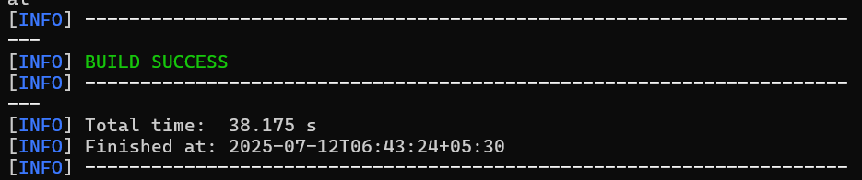

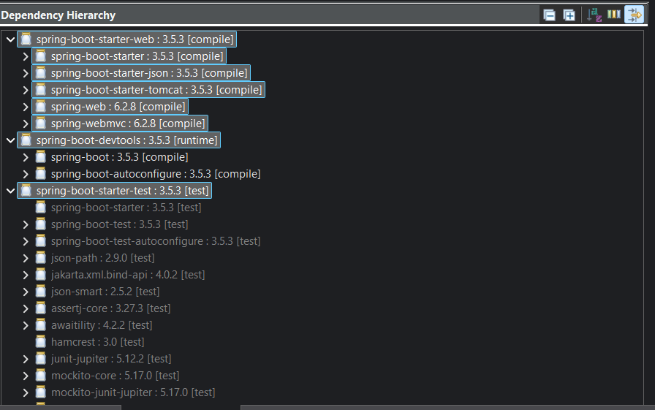

**Hands on 2**

**Spring Core – Load SimpleDateFormat from Spring Configuration XML** 

XML ;

<?xml version="1.0" encoding="UTF-8"?>

<beans xmlns="http://www.springframework.org/schema/beans"

xmlns:xsi="http://www.w3.org/2001/XMLSchema-instance"

xsi:schemaLocation="http://www.springframework.org/schema/beans

https://www.springframework.org/schema/beans/spring-beans.xsd">

<bean id="dateFormat" class="java.text.SimpleDateFormat">

<constructor-arg value="dd/MM/yyyy" />

</bean>

</beans>

CODE:

package com.cognizant.spring_learn;

import org.slf4j.Logger;

import org.slf4j.LoggerFactory;

import org.springframework.context.ApplicationContext;

import org.springframework.context.support.ClassPathXmlApplicationContext;

import java.text.SimpleDateFormat;

import java.util.Date;

import org.springframework.boot.SpringApplication;

import org.springframework.boot.autoconfigure.SpringBootApplication;

*@SpringBootApplication*

public class SpringLearnApplication {

private static final Logger ***LOGGER*** = LoggerFactory.*getLogger*(SpringLearnApplication.class);

public static void main(String[] args) {

SpringApplication.*run*(SpringLearnApplication.class, args);

***LOGGER***.info("START");

*displayDate*();

***LOGGER***.info("END");

}

public static void displayDate() {

ApplicationContext context = new ClassPathXmlApplicationContext("date-format.xml");

SimpleDateFormat format = context.getBean("dateFormat", SimpleDateFormat.class);

try {

Date date = format.parse("31/12/2018");

***LOGGER***.debug("Parsed Date: {}", date);

} catch (Exception e) {

***LOGGER***.error("Date parsing failed", e);

}

}

}

OUTPUT:

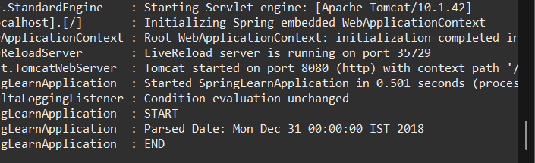

**Hands on 3**

**Spring Core - Incorporate Logging**   
  
**Properties Added:**

.level.org.springframework=info

logging.level.com.cognizant.spring_learn=debug

logging.pattern.console=%d{yyMMdd}|%d{HH:mm:ss.SSS}|%-20.20thread|%5p|%-25.25logger{25}|%25M|%m%n

**Updated Code :**

package com.cognizant.spring_learn;

import org.slf4j.Logger;

import org.slf4j.LoggerFactory;

import org.springframework.context.ApplicationContext;

import org.springframework.context.support.ClassPathXmlApplicationContext;

import java.text.SimpleDateFormat;

import java.util.Date;

import org.springframework.boot.SpringApplication;

import org.springframework.boot.autoconfigure.SpringBootApplication;

*@SpringBootApplication*

public class SpringLearnApplication {

private static final Logger ***LOGGER*** = LoggerFactory.*getLogger*(SpringLearnApplication.class);

public static void main(String[] args) {

SpringApplication.*run*(SpringLearnApplication.class, args);

***LOGGER***.info("START");

*displayDate*();

***LOGGER***.info("END");

}

public static void displayDate() {

***LOGGER***.info("START");

ApplicationContext context = new ClassPathXmlApplicationContext("date-format.xml");

SimpleDateFormat format = context.getBean("dateFormat", SimpleDateFormat.class);

try {

Date date = format.parse("31/12/2018");

***LOGGER***.debug("Parsed Date: {}", date);

} catch (Exception e) {

***LOGGER***.error("Date parsing failed", e);

}

***LOGGER***.info("END");

}

}

**OUTPUT:**

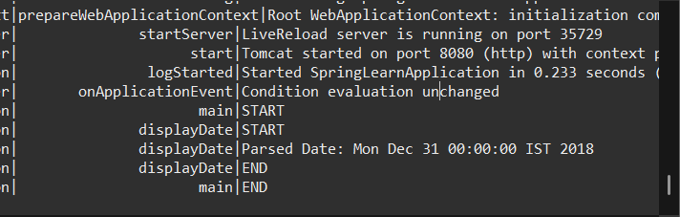

**Hands on 4**

**Spring Core – Load Country from Spring Configuration XML**

**Steps to implement**

* **Pick any one of your choice country to configure in Spring XML configuration named country.xml.**
* **Create a method displayCountry() in SpringLearnApplication.java, which will read the country bean from spring configuration file and display the country**
* **Invoke displayCountry() method in main() method of SpringLearnApplication.java.**
* **Execute main() method and check the logs to find out which constructors and methods were invoked.**

**CODE:**

**Country.xml:**

<?xml version="1.0" encoding="UTF-8"?>

<beans xmlns="http://www.springframework.org/schema/beans"

xmlns:xsi="http://www.w3.org/2001/XMLSchema-instance"

xsi:schemaLocation="

http://www.springframework.org/schema/beans

https://www.springframework.org/schema/beans/spring-beans.xsd">

<bean id="country" class="com.cognizant.spring_learn.Country">

<property name="code" value="IN" />

<property name="name" value="India" />

</bean>

</beans>

**Country.java:**

package com.cognizant.spring_learn;

import org.slf4j.Logger;

import org.slf4j.LoggerFactory;

public class Country {

private static final Logger ***LOGGER*** = LoggerFactory.*getLogger*(Country.class);

private String code;

private String name;

public Country() {

***LOGGER***.debug("Inside Country Constructor.");

}

public String getCode() {

***LOGGER***.debug("getCode called");

return code;

}

public void setCode(String code) {

***LOGGER***.debug("setCode called");

this.code = code;

}

public String getName() {

***LOGGER***.debug("getName called");

return name;

}

public void setName(String name) {

***LOGGER***.debug("setName called");

this.name = name;

}

*@Override*

public String toString() {

return "Country [code=" + code + ", name=" + name + "]";

}

}

**SpringLearnApplication.java:**

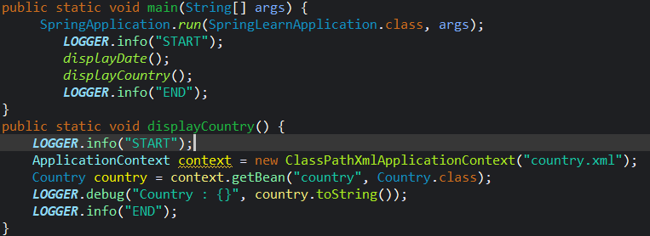

**OUTPUT:**

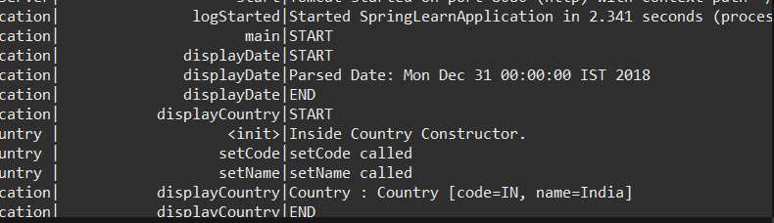

**Hands on 5**

**Spring Core – Demonstration of Singleton Scope and Prototype Scope**   
  
Run the application

* Constructor will be called twice, which means that two instances of country is created.

**Country method:**

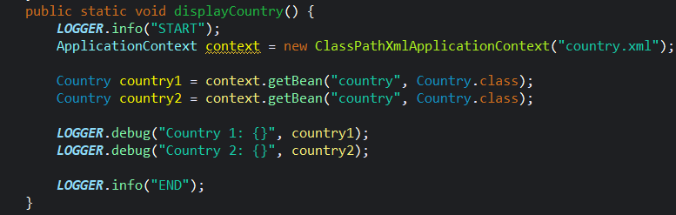

**Country.xml :**

<?xml version="1.0" encoding="UTF-8"?>

<beans xmlns="http://www.springframework.org/schema/beans"

xmlns:xsi="http://www.w3.org/2001/XMLSchema-instance"

xsi:schemaLocation="

http://www.springframework.org/schema/beans

https://www.springframework.org/schema/beans/spring-beans.xsd">

<bean id="country" class="com.cognizant.spring_learn.Country" scope="prototype">

<property name="code" value="IN" />

<property name="name" value="India" />

</bean>

</beans>

**OUTPUT:**

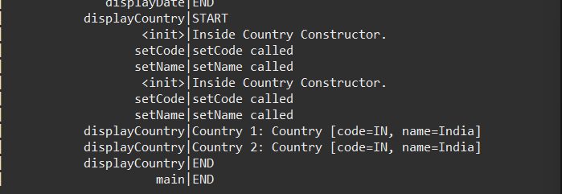

**Hands on 6**

**Spring Core – Load list of countries from Spring Configuration XML**   
  
Our main objective was to retrieve the list of four countries for the airlines website. Refer steps below to get this incorporated. 

* Create a separate bean for each of the four country in country.xml.
* Create an ArrayList of Country in country.xml. Refer code below.

    <bean id="countryList" class="java.util.ArrayList">

        <constructor-arg>

            <list>

                <ref bean="in"></ref>

                <ref bean="us"></ref>

                <ref bean="de"></ref>

                <ref bean="jp"></ref>

            </list>

        </constructor-arg>

    </bean>

* Include new method displayCountries() in SpringLearnApplication.java
* In displayCountries() read the country list created above
* Display the list of countries as debug log.

SME to provide detailing on below aspects:

* <list>
* <ref>
* bean attribute

**IMPORTANT NOTE**: Do not forget to include the start and end logs in this new metho]

**Country.xml:**

<?xml version="1.0" encoding="UTF-8"?>

<beans xmlns="http://www.springframework.org/schema/beans"

xmlns:xsi="http://www.w3.org/2001/XMLSchema-instance"

xsi:schemaLocation="http://www.springframework.org/schema/beans

https://www.springframework.org/schema/beans/spring-beans.xsd">

<bean id="in" class="com.cognizant.spring_learn.Country">

<property name="code" value="IN" />

<property name="name" value="India" />

</bean>

<bean id="us" class="com.cognizant.spring_learn.Country">

<property name="code" value="US" />

<property name="name" value="United States" />

</bean>

<bean id="de" class="com.cognizant.spring_learn.Country">

<property name="code" value="DE" />

<property name="name" value="Germany" />

</bean>

<bean id="jp" class="com.cognizant.spring_learn.Country">

<property name="code" value="JP" />

<property name="name" value="Japan" />

</bean>

<bean id="countryList" class="java.util.ArrayList">

<constructor-arg>

<list>

<ref bean="in"/>

<ref bean="us"/>

<ref bean="de"/>

<ref bean="jp"/>

</list>

</constructor-arg>

</bean>

</beans>

DisplayCountry()

public static void displayCountry() {

***LOGGER***.info("START");

ApplicationContext context = new ClassPathXmlApplicationContext("country.xml");

Country country1 = context.getBean("in", Country.class);

Country country2 = context.getBean("in", Country.class);

***LOGGER***.debug("Country 1: {}", country1);

***LOGGER***.debug("Country 2: {}", country2);

***LOGGER***.info("END");

}

**OUTPUT:**

